Requirements/Design Specification

**Update Assign Quote Email**

**GH 525 – CR 13927**

Revision History

|  |  |  |  |
| --- | --- | --- | --- |
| **Date** | **Revision** | **Description** | **Author** |
| 4/29/2015 | 1.0 | Initial Version with Requirements | Roger Behm |
|  |  |  |  |
|  |  |  |  |
|  |  |  |  |
|  |  |  |  |

The information furnished herein by Republic Services Inc. is proprietary and confidential to Republic Services Inc. personnel and is not to be duplicated, published, or disclosed to any third party in whole or in part without permission from Republic Services, Inc.

© Copyright 2012, Republic Services Inc. - All rights reserved.

Table of contents

1 Business Requirements/Owner – Brittany Smith 6

1.1 Purpose of the Design Specification 6

2 Assumptions 6

3 Design 6

4 InfoPro/TIBCO/BI Impacts 6

5 Report Changes 6

6 Appendix 6

# Business Requirements/Owner – Brittany Smith

## Purpose of the Design Specification

If we update the information in the Assigned Quote email, the Sales Coordinator may be able to more quickly determine who to assign the quote to. We should expect to see an increase in this request as the call centers onboard.

Also, fix quote owner, sales rep on Proposal for Cover Letter new quote owner.

Want ability to open window and add comments from the user.

1. Full Address with zip code
2. Site/Company Name
3. Perm or Temp
4. LOB
5. Rep or CSR Name that started the quote (email is from this person, but please add to body)

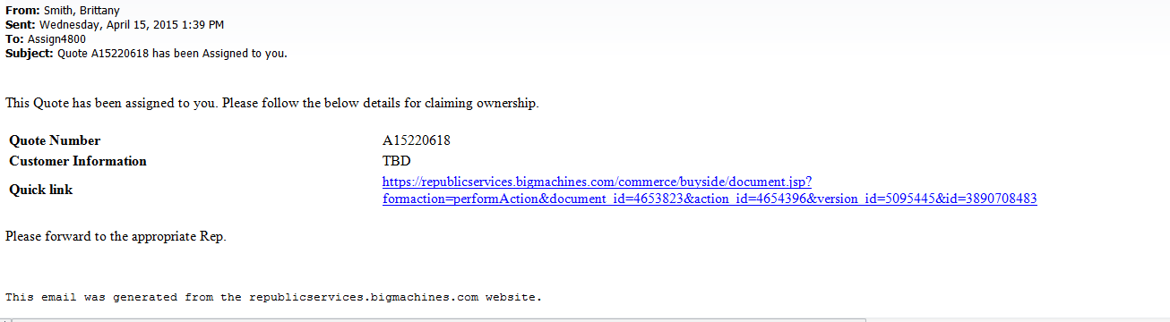

# Assumptions

NA

# Design

Update data points on the assign_quote email doc within Capture with the ones above.

# InfoPro/TIBCO/BI Impacts

No new variable should be needed and no existing variables should be repurposed for any of the above changes.

# Report Changes

NA

# Appendix